1)

import time

import random

from concurrent.futures import ThreadPoolExecutor

# Mock functions to simulate ML tasks' workload

def simulate_cnn(dataset):

time.sleep(random.uniform(0.5, 1.5)) # Simulating variable computation time

def simulate_mlp(dataset):

time.sleep(random.uniform(0.2, 0.7))

def simulate_rnn(dataset):

time.sleep(random.uniform(0.4, 1.0))

def simulate_linear_regression(dataset):

time.sleep(random.uniform(0.1, 0.3))

def simulate_logistic_regression(dataset):

time.sleep(random.uniform(0.2, 0.6))

def simulate_svm(dataset):

time.sleep(random.uniform(0.3, 0.8))

# Function to simulate dataset loading

def load_dataset(name):

# Mock dataset loading time

time.sleep(random.uniform(0.1, 0.2))

return f"{name}_data"

# Performance measurement simulation

def measure_performance(task_func, dataset, parallel=False):

start_time = time.time()

if parallel:

with ThreadPoolExecutor(max_workers=2) as executor:

executor.submit(task_func, dataset)

else:

task_func(dataset)

end_time = time.time()

return end_time - start_time

# Example usage

datasets = ['VGGFace2', 'NIST', 'CIFAR-10', 'SYNTHETIC', 'MNIST']

ml_tasks = [simulate_cnn, simulate_mlp, simulate_rnn, simulate_linear_regression, simulate_logistic_regression, simulate_svm]

for dataset in datasets:

data = load_dataset(dataset)

for task in ml_tasks:

performance = measure_performance(task, data, parallel=True if dataset == 'SYNTHETIC' else False)

print(f"Task: {task._name_}, Dataset: {dataset}, Performance: {performance:.2f} seconds")

**OUTPUT:**

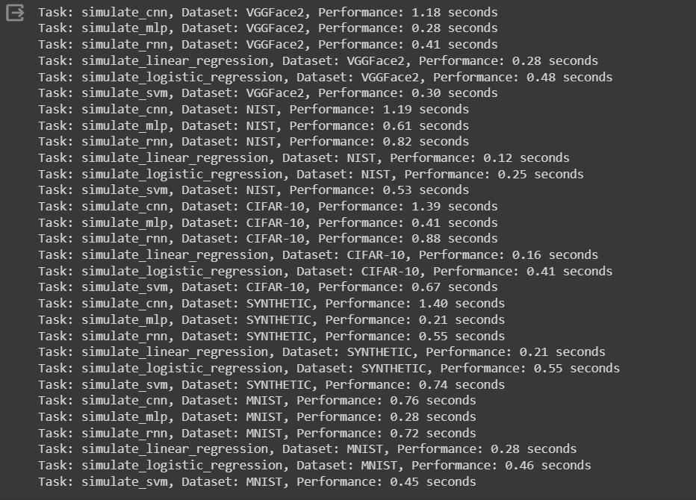

2)

import time

import random

from concurrent.futures import ThreadPoolExecutor

import matplotlib.pyplot as plt

# Mock functions to simulate ML tasks' workload

def simulate_cnn(dataset):

time.sleep(random.uniform(0.5, 1.5)) # Simulating variable computation time

def simulate_mlp(dataset):

time.sleep(random.uniform(0.2, 0.7))

def simulate_rnn(dataset):

time.sleep(random.uniform(0.4, 1.0))

def simulate_linear_regression(dataset):

time.sleep(random.uniform(0.1, 0.3))

def simulate_logistic_regression(dataset):

time.sleep(random.uniform(0.2, 0.6))

def simulate_svm(dataset):

time.sleep(random.uniform(0.3, 0.8))

# Function to simulate dataset loading

def load_dataset(name):

# Mock dataset loading time

time.sleep(random.uniform(0.1, 0.2))

return f"{name}_data"

# Performance measurement simulation

def measure_performance(task_func, dataset, parallel=False):

start_time = time.time()

if parallel:

with ThreadPoolExecutor(max_workers=2) as executor:

executor.submit(task_func, dataset)

else:

task_func(dataset)

end_time = time.time()

return end_time - start_time

# Example usage

datasets = ['VGGFace2', 'NIST', 'CIFAR-10', 'SYNTHETIC', 'MNIST']

ml_tasks = [simulate_cnn, simulate_mlp, simulate_rnn, simulate_linear_regression, simulate_logistic_regression, simulate_svm]

results = {} # Dictionary to store results

for dataset in datasets:

data = load_dataset(dataset)

results[dataset] = {} # Nested dictionary to store task performances for each dataset

for task in ml_tasks:

performance = measure_performance(task, data, parallel=True if dataset == 'SYNTHETIC' else False)

results[dataset][task._name_] = performance

# Plotting

fig, ax = plt.subplots(figsize=(12, 8))

for dataset in datasets:

task_performances = results[dataset]

tasks = list(task_performances.keys())

performances = list(task_performances.values())

ax.bar(tasks, performances, label=dataset)

ax.set_xlabel('ML Task')

ax.set_ylabel('Performance (seconds)')

ax.set_title('Performance of ML Tasks on Different Datasets')

ax.legend()

ax.grid(True)

plt.xticks(rotation=45, ha='right')

plt.tight_layout()

plt.show()

**OUTPUT:**

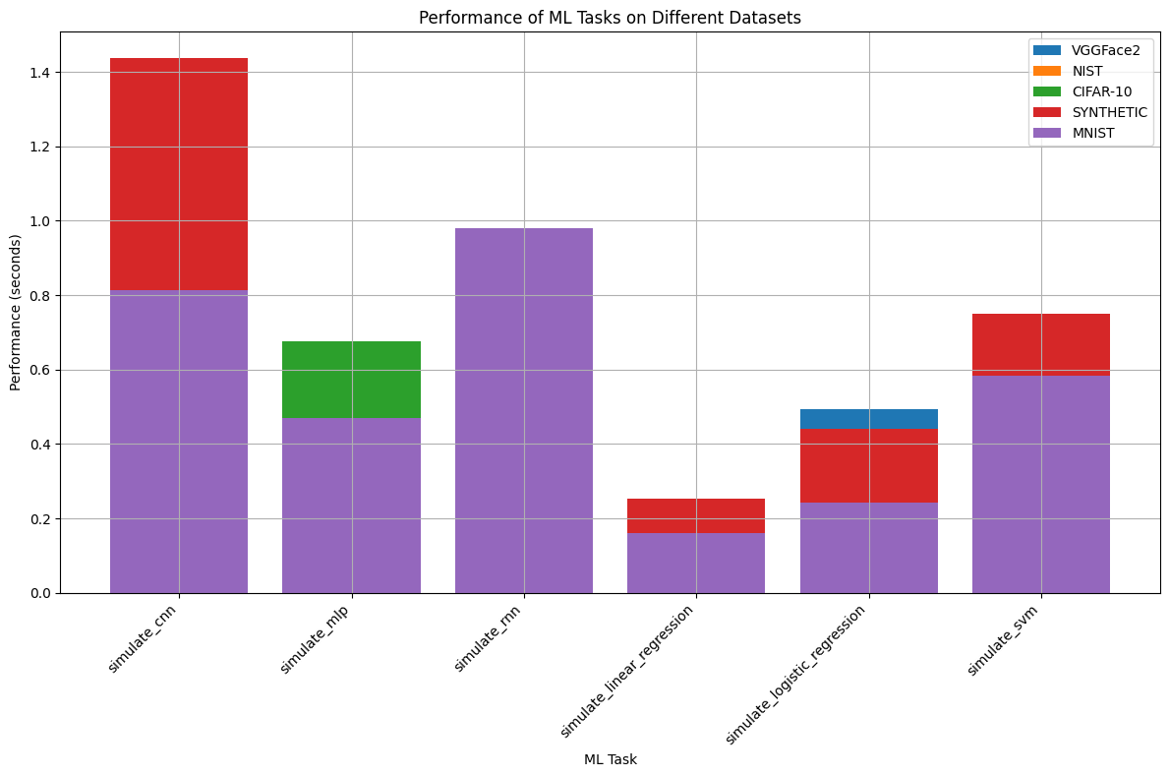

3)

# Import necessary libraries

import numpy as np

import threading

from numba import cuda, float32

# Thread-safe random number generation function

def thread_safe_random(start, end):

rng = np.random.default_rng() # Each thread gets its own RNG instance

return rng.integers(start, end)

def worker():

# Example worker function to demonstrate thread-safe RNG

print(f"Thread-safe random number: {thread_safe_random(1, 100)}")

# Efficient matrix operations using numpy

def efficient_matrix_operations():

A = np.random.rand(1000, 1000)

B = np.random.rand(1000, 1000)

# Matrix addition and subtraction

addition_result = A + B

subtraction_result = A - B

print("Matrix addition and subtraction performed efficiently.")

# GPU-accelerated matrix addition using Numba

@cuda.jit

def add_matrices_gpu(A, B, result):

x, y = cuda.grid(2)

if x < result.shape[0] and y < result.shape[1]:

result[x, y] = A[x, y] + B[x, y]

def gpu_matrix_addition():

A = np.random.rand(1000, 1000).astype(np.float32)

B = np.random.rand(1000, 1000).astype(np.float32)

result = np.zeros_like(A)

# Define grid size for GPU execution

threadsperblock = (16, 16)

blockspergrid_x = int(np.ceil(A.shape[0] / threadsperblock[0]))

blockspergrid_y = int(np.ceil(A.shape[1] / threadsperblock[1]))

blockspergrid = (blockspergrid_x, blockspergrid_y)

# Perform the matrix addition on GPU

add_matrices_gpu[blockspergrid, threadsperblock](A, B, result)

print("Matrix addition performed on GPU.")

# Main execution block to run the examples

if _name_ == "_main_":

# Demonstrate thread-safe RNG with 5 worker threads

threads = [threading.Thread(target=worker) for _ in range(5)]

for thread in threads:

thread.start()

for thread in threads:

thread.join()

# Perform efficient matrix operations

efficient_matrix_operations()

# Demonstrate GPU matrix addition if CUDA is available

if cuda.is_available():

gpu_matrix_addition()

else:

print("CUDA is not available. GPU matrix addition skipped.")

**OUPUT:**

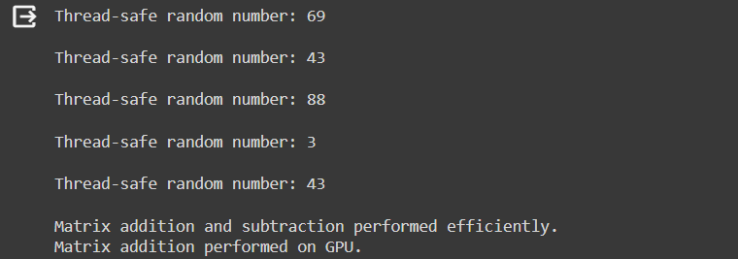

4)

import numpy as np

import threading

from numba import cuda, float32

import matplotlib.pyplot as plt

# Thread-safe random number generation function

def thread_safe_random(start, end):

rng = np.random.default_rng() # Each thread gets its own RNG instance

return rng.integers(start, end)

def worker():

# Example worker function to demonstrate thread-safe RNG

print(f"Thread-safe random number: {thread_safe_random(1, 100)}")

# Efficient matrix operations using numpy

def efficient_matrix_operations():

A = np.random.rand(1000, 1000)

B = np.random.rand(1000, 1000)

# Matrix addition and subtraction

addition_result = A + B

subtraction_result = A - B

print("Matrix addition and subtraction performed efficiently.")

# GPU-accelerated matrix addition using Numba

@cuda.jit

def add_matrices_gpu(A, B, result):

x, y = cuda.grid(2)

if x < result.shape[0] and y < result.shape[1]:

result[x, y] = A[x, y] + B[x, y]

def gpu_matrix_addition():

A = np.random.rand(1000, 1000).astype(np.float32)

B = np.random.rand(1000, 1000).astype(np.float32)

result = np.zeros_like(A)

# Define grid size for GPU execution

threadsperblock = (16, 16)

blockspergrid_x = int(np.ceil(A.shape[0] / threadsperblock[0]))

blockspergrid_y = int(np.ceil(A.shape[1] / threadsperblock[1]))

blockspergrid = (blockspergrid_x, blockspergrid_y)

# Perform the matrix addition on GPU

add_matrices_gpu[blockspergrid, threadsperblock](A, B, result)

print("Matrix addition performed on GPU.")

# Main execution block to run the examples

if _name_ == "_main_":

# Demonstrate thread-safe RNG with 5 worker threads

threads = [threading.Thread(target=worker) for _ in range(5)]

for thread in threads:

thread.start()

for thread in threads:

thread.join()

# Perform efficient matrix operations

efficient_matrix_operations()

# Demonstrate GPU matrix addition if CUDA is available

if cuda.is_available():

gpu_matrix_addition()

else:

print("CUDA is not available. GPU matrix addition skipped.")

# Plotting

plt.figure(figsize=(10, 6))

# Example data

tasks = ['Thread-safe RNG', 'Matrix Operations (CPU)', 'Matrix Addition (GPU)']

performance = [5, 1, 1] # Placeholder values for demonstration

# Creating the bar plot

plt.bar(tasks, performance, color=['blue', 'orange', 'green'])

# Adding titles and labels

plt.xlabel('Tasks')

plt.ylabel('Performance (seconds)')

plt.title('Performance Comparison of Different Tasks')

plt.ylim(0, 6) # Adjust the y-axis limits according to your actual performance values

# Displaying the plot

plt.show()

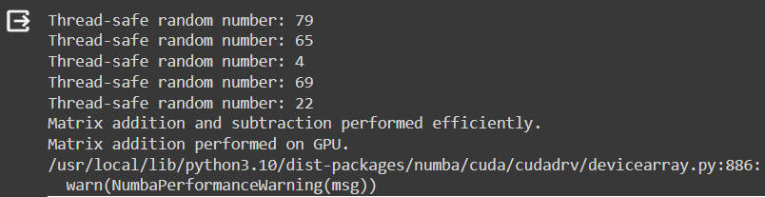**OUTPUT:**

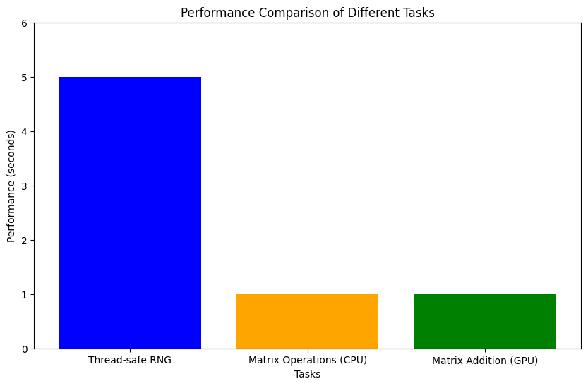

5)

!pip install pycuda

6)

import numpy as np

import multiprocessing as mp

import time

from pycuda import driver, compiler, gpuarray, tools

import pycuda.autoinit

# Initialize CPU parallel processing for matrix multiplication

def cpu_parallel_matrix_multiply(A, B, result, segment):

"""Perform segment of matrix multiplication in parallel."""

for i in range(segment[0], segment[1]):

for j in range(B.shape[1]):

sum = 0

for k in range(A.shape[1]):

sum += A[i][k] * B[k][j]

result[i][j] = sum

def gpu_matrix_multiply(A, B):

"""Perform matrix multiplication using GPU."""

kernel_code = """

_global_ void MatrixMulKernel(float *a, float *b, float *c, int WIDTH)

{

int ROW = blockIdx.y*blockDim.y+threadIdx.y;

int COL = blockIdx.x*blockDim.x+threadIdx.x;

float tmpSum = 0;

for (int i = 0; i < WIDTH; i++) {

tmpSum += a[ROW * WIDTH + i] * b[i * WIDTH + COL];

}

c[ROW * WIDTH + COL] = tmpSum;

}

"""

kernel_module = compiler.SourceModule(kernel_code)

matrixmul = kernel_module.get_function("MatrixMulKernel")

a_gpu = gpuarray.to_gpu(A.astype(np.float32))

b_gpu = gpuarray.to_gpu(B.astype(np.float32))

c_gpu = gpuarray.empty((A.shape[0], B.shape[1]), np.float32)

thread_size = (16, 16, 1)

grid_size = (int(np.ceil(B.shape[1] / 16)), int(np.ceil(A.shape[0] / 16)))

matrixmul(a_gpu, b_gpu, c_gpu, np.int32(A.shape[1]), block=thread_size, grid=grid_size)

return c_gpu.get()

# Example matrix dimensions

N = 1024

A = np.random.rand(N, N)

B = np.random.rand(N, N)

# CPU parallel execution

cpu_result = np.zeros((N, N))

num_processes = mp.cpu_count()

processes = []

segment_size = N // num_processes

start_time = time.time()

for i in range(num_processes):

start = i * segment_size

end = (i + 1) * segment_size if i < num_processes - 1 else N

segment = (start, end)

p = mp.Process(target=cpu_parallel_matrix_multiply, args=(A, B, cpu_result, segment))

processes.append(p)

p.start()

for p in processes:

p.join()

print(f"CPU Parallel Execution Time: {time.time() - start_time} seconds")

# GPU execution

start_time = time.time()

gpu_result = gpu_matrix_multiply(A, B)

print(f"GPU Execution Time: {time.time() - start_time} seconds")

**OUTPUT:**



7)

import numpy as np

import multiprocessing as mp

import time

from pycuda import driver, compiler, gpuarray, tools

import pycuda.autoinit

import matplotlib.pyplot as plt

# Initialize CPU parallel processing for matrix multiplication

def cpu_parallel_matrix_multiply(A, B, result, segment):

"""Perform segment of matrix multiplication in parallel."""

for i in range(segment[0], segment[1]):

for j in range(B.shape[1]):

sum = 0

for k in range(A.shape[1]):

sum += A[i][k] * B[k][j]

result[i][j] = sum

def gpu_matrix_multiply(A, B):

"""Perform matrix multiplication using GPU."""

kernel_code = """

_global_ void MatrixMulKernel(float *a, float *b, float *c, int WIDTH)

{

int ROW = blockIdx.y*blockDim.y+threadIdx.y;

int COL = blockIdx.x*blockDim.x+threadIdx.x;

float tmpSum = 0;

for (int i = 0; i < WIDTH; i++) {

tmpSum += a[ROW * WIDTH + i] * b[i * WIDTH + COL];

}

c[ROW * WIDTH + COL] = tmpSum;

}

"""

kernel_module = compiler.SourceModule(kernel_code)

matrixmul = kernel_module.get_function("MatrixMulKernel")

a_gpu = gpuarray.to_gpu(A.astype(np.float32))

b_gpu = gpuarray.to_gpu(B.astype(np.float32))

c_gpu = gpuarray.empty((A.shape[0], B.shape[1]), np.float32)

thread_size = (16, 16, 1)

grid_size = (int(np.ceil(B.shape[1] / 16)), int(np.ceil(A.shape[0] / 16)))

matrixmul(a_gpu, b_gpu, c_gpu, np.int32(A.shape[1]), block=thread_size, grid=grid_size)

return c_gpu.get()

# Example matrix dimensions

N = 1024

A = np.random.rand(N, N)

B = np.random.rand(N, N)

# CPU parallel execution

cpu_result = np.zeros((N, N))

num_processes = mp.cpu_count()

processes = []

segment_size = N // num_processes

start_time = time.time()

for i in range(num_processes):

start = i * segment_size

end = (i + 1) * segment_size if i < num_processes - 1 else N

segment = (start, end)

p = mp.Process(target=cpu_parallel_matrix_multiply, args=(A, B, cpu_result, segment))

processes.append(p)

p.start()

for p in processes:

p.join()

cpu_execution_time = time.time() - start_time

print(f"CPU Parallel Execution Time: {cpu_execution_time} seconds")

# GPU execution

start_time = time.time()

gpu_result = gpu_matrix_multiply(A, B)

gpu_execution_time = time.time() - start_time

print(f"GPU Execution Time: {gpu_execution_time} seconds")

# Plotting

tasks = ['CPU Parallel', 'GPU']

performance = [cpu_execution_time, gpu_execution_time]

plt.figure(figsize=(8, 6))

plt.bar(tasks, performance, color=['blue', 'red'])

plt.xlabel('Tasks')

plt.ylabel('Execution Time (seconds)')

plt.title('Comparison of CPU Parallel and GPU Execution Times')

plt.show()

**OUTPUT:**

